**BANK LOAN ANALYSIS QUERY DOCUMENT**

A). BANK LOAN REPORT| **SUMMARY**

KPI’s

**1). Total Loan applications**  
-*Calculates the total number of applications*

SELECT COUNT(ID) AS Total_loan_applications FROM financial_loan;  


**a). MTD Loan Applications**  
-*calculates the total number of loan applications in a month, that is, December 2021.  
 (MTD-Month To Date)*  
  
SELECT count(id) AS MTD_Total_loan_applications FROM financial_loan  
WHERE MONTH (issue_date) =12 AND YEAR (issue_date) =2021;



**b). PMTD Loan Applications***-calculates the total number of loan applications for the previous month, that is November 2021.  
(PMTD-Previous Month To Date)*

SELECT count(id) AS PMTD_Total_loan_applications FROM financial_loan  
WHERE MONTH (issue_date) =11 AND YEAR (issue_date) =2021;



**2.Total Funded amount***- Calculates the total funded amount across all applications*

SELECT SUM (loan_amount) AS Total_funded_amount FROM financial_loan;  


**a). MTD Funded Amount**  
*-calculates the month to date total funded amount in a month, that is December 2021.*  
SELECT SUM (loan_amount) AS MTD_Total_funded_amount FROM financial_loan  
WHERE MONTH (issue_date) =12 AND YEAR (issue_date) =2021;  


**b). PMTD Funded Amount  
*-*** *calculates the month to date total funded amount for the previous month, that is November 2021.*  
SELECT SUM (loan_amount) AS PMTD_Total_funded_amount FROM financial_loan  
WHERE MONTH (issue_date) =11 AND YEAR (issue_date) =2021;



**3. Total Amount received  
*-****Calculates the total amount collected from lending of loan.*

SELECT SUM (total_payment) AS Total_amt_received FROM financial_loan;  


**a). MTD Total Amount received**  
*-Calculates the month to date total amount collected from lending of loans in December 2021.*

SELECT SUM (total_payment) AS MTD_Total_amt_received FROM financial_loan  
WHERE MONTH (issue_date) =12 AND YEAR (issue_date) =2021;  


**b) PMTD Total Amount received**  
*-Calculates the month to date total amount collected from lending of loans for previous month, that is November 2021.*

SELECT SUM (total_payment) AS PMTD_Total_amt_received FROM financial_loan  
WHERE MONTH (issue_date) =11 AND YEAR (issue_date) =2021;  


**4. Average Interest Rate***-Calculates the average interest rate across all loan applications.*  
SELECT ROUND (AVG (int_rate) *100,2) AS Avg_int_rate FROM financial_loan;



**a). MTD Average Interest Rate**  
*- Calculates the month to date average interest rate for loan applications in December 2021.*

SELECT ROUND (AVG (int_rate) *100,2) AS MTD_Avg_int_rate FROM financial_loan  
WHERE MONTH (issue_date) =12 AND YEAR (issue_date) =2021;



**b). PMTD Average Interest Rate**  
*- Calculates the previous month to date average interest rate for loan applications in November 2021.*

SELECT ROUND (AVG (int_rate) *100,2) AS PMTD_Avg_int_rate FROM financial_loan  
WHERE MONTH (issue_date) =11 AND YEAR (issue_date) =2021;



**5. Average DTI**  
*-Calculates the average Debt-to-Income ratio across all loan applications.*SELECT ROUND (AVG (dti)*100,2) AS Avg_dti FROM financial_loan;

  
   
**a). MTD Average DTI**  
*-Calculates the month-to-date (MTD) average Debt-to-Income for loan applications in December 2021.*

SELECT ROUND (AVG (dti)*100,2) AS MTD_Avg_dti   
FROM financial_loan  
WHERE MONTH (issue_date) =12 AND YEAR (issue_date) =2021;



**b). PMTD Average DTI**  
*-Calculates the previous month-to-date (PMTD) average Debt-to-Income for loan applications in November 2021.*

SELECT ROUND (AVG (dti)*100,2) AS PMTD_Avg_dti   
FROM financial_loan  
WHERE MONTH (issue_date) =12 AND YEAR (issue_date) =2021;



**Good Loan v Bad Loan KPI’s**

**Good Loan KPIs:**

**1). Good Loan Application Percentage:  
*-*** *Calculates the percentage of loans that are 'Fully Paid' or 'Current'.*

SELECT  
 ROUND ((COUNT (CASE WHEN loan_status IN ("Fully paid", "current") THEN ID END)) /   
 Count(id)*100,2) AS Good_loan_applications_percentage   
FROM financial_loan;

  
  
2). **Good Loan Applications:**-*Calculates the number of loan applications that are classified as 'Fully Paid' or 'Current'.*

SELECT count(id) AS Total_Good_loan_applications   
FROM financial_loan  
WHERE loan_status IN ("fully paid", "current");



**3). Good Loan Funded Amount:**   
-*Calculates the total funded amount across all loan applications that are classified as 'Fully Paid' or ‘Current’.*

SELECT SUM (loan_amount) AS Good_Loan_Funded_Amount   
FROM financial_loan  
WHERE loan_status IN ("fully paid", "current");



**4). Good Loan Total Received Amount:**   
*-Calculates the total amount received from the customers for loan applications that are classified as 'Fully Paid' or ‘Current’.*  
  
SELECT SUM (total_payment) AS Good_Loan_Total_Received_Amount

FROM financial_loan  
WHERE loan_status IN ("fully paid", "current");



**Bad Loan KPIs:**

**1).** **Bad Loan Application Percentage:***Calculates the percentage of loans that are 'Charged off'.*

SELECT   
 ROUND ((COUNT (CASE WHEN loan_status='charged off' THEN id end)/  
 count(id)*100),2) AS Bad_Loan_Applications_percentage   
FROM financial_loan;



**2.Bad Loan Applications:**

*-Calculates the number of loan applications that are classified as 'Charged off'.*

SELECT COUNT(ID) AS Bad_Loan_Applications  
FROM financial_loan  
WHERE loan_status='charged off';



**3.Bad Loan Funded Amount:***-Calculates the total funded amount across all loan applications that are classified as 'Charged off'.*

SELECT SUM (loan_amount) AS Bad_Loan_Funded_Amount   
FROM financial_loan  
WHERE loan_status='charged off';



**4.Bad Loan Total Received Amount:**Calculates the total amount received from the customers for loan applications that are classified as ‘Charged off’.

SELECT SUM (total_payment) AS Bad_Loan_Total_Received_Amount   
FROM financial_loan  
WHERE loan_status='charged off';



**Loan Status Grid View**

SELECT loan_status,count(id) AS Total_loan_applications,  
 SUM(loan_amount) AS Total_funded_amount,  
 SUM(total_payment) AS Total_amt_received,  
 ROUND(AVG(int_rate)*100,2) AS Avg_int_rate,  
 ROUND(AVG(dti)*100,2) AS Avg_dti  
 FROM financial_loan  
 GROUP BY loan_status;  
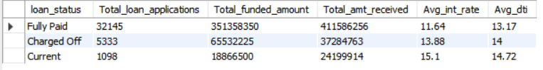

SELECT loan_status,

SUM(loan_amount) AS MTD_Total_funded_amount,

SUM(total_payment) AS MTD_Total_amt_received  
 FROM financial_loan

WHERE MONTH(issue_date)=12

GROUP BY loan_status;

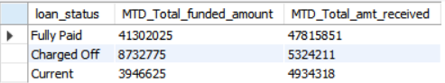

B). BANK LOAN REPORT| **OVERVIEW**

**1). Monthly Trends by Issue Date:***--retrieves monthly overview statistics, including month number, month name, total loan applications, total funded amount and total amount received.*

SELECT MONTH(issue_date),

MONTHNAME(issue_date),

COUNT(ID) AS Total_loan_applications,

SUM(loan_amount) AS Total_funded_amount,

SUM(total_payment) AS Total_amt_received FROM financial_loan

GROUP BY MONTH(issue_date),MONTHNAME(issue_date)

ORDER BY MONTH(issue_date);

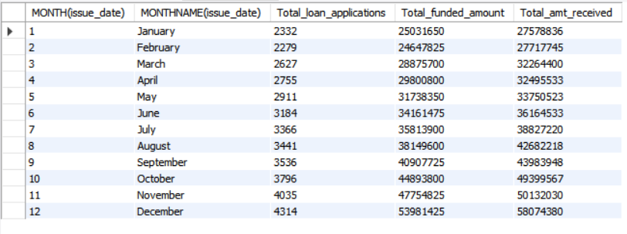

**2). Regional Analysis by State:**

--*retrieves state-wise overview statistics including state name, total loan applications, total funded amount and total amount received.*

SELECT address_state,  
 COUNT(ID) AS Total_loan_applications,  
 SUM(loan_amount) AS Total_funded_amount,  
 SUM(total_payment) AS Total_amt_received  
FROM financial_loan

GROUP BY address_state

ORDER BY COUNT(ID) DESC;

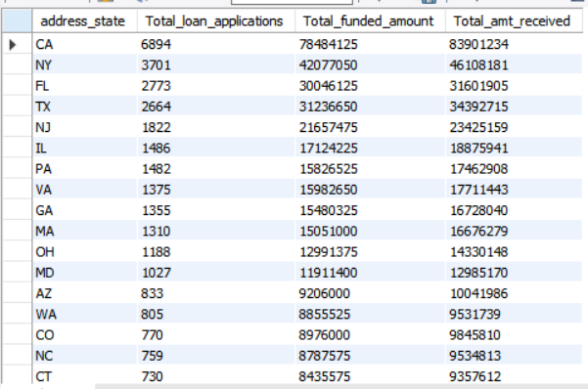

**3). Loan Term Analysis:**-*retrieves loan term wise statistics, including the loan term or duration, total loan applications, total funded amount and total amount received.*

SELECT term,

COUNT(ID) AS Total_loan_applications,  
 SUM(loan_amount) AS Total_funded_amount,  
 SUM(total_payment) AS Total_amt_received   
FROM financial_loan

GROUP BY term;

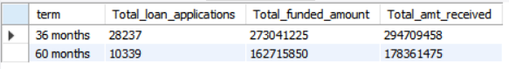

**4). Employee Length Analysis:**-*retrieves borrower’s employment length analysis, including the employee length (employment length), total loan applications, total funded amount and total amount received*.

SELECT emp_length,  
 COUNT(ID) AS Total_loan_applications,  
 SUM(loan_amount) AS Total_funded_amount,  
 SUM(total_payment) AS Total_amt_received   
FROM financial_loan

GROUP BY emp_length

ORDER BY emp_length;

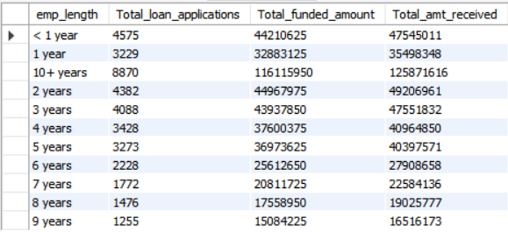

**5. Loan Purpose Breakdown:**  
*-retrieves loan purpose overview statistics, including purpose of borrower for taking loan, total loan applications, total funded amount and total amount received.*

SELECT purpose,  
 COUNT(ID) AS Total_loan_applications,  
 SUM(loan_amount) AS Total_funded_amount,  
 SUM(total_payment) AS Total_amt_received  
FROM financial_loan

GROUP BY purpose;

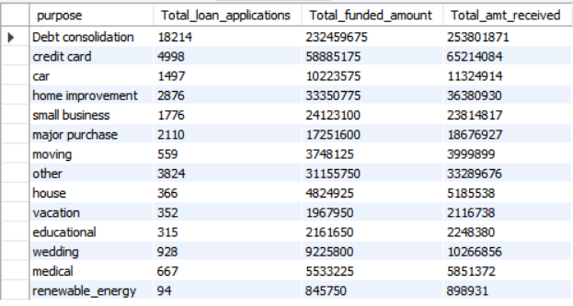

**6. Home Ownership Analysis:**  
*-retrieves home ownership overview statistics, including the borrower’s home ownership status, total loan applications, total funded amount and total amount received.*

SELECT home_ownership,  
 COUNT(ID) AS Total_loan_applications,  
 SUM(loan_amount) AS Total_funded_amount,  
 SUM(total_payment) AS Total_amt_received   
FROM financial_loan

GROUP BY home_ownership;

